In this project I decided to do “Truck Simulation marketing” for my tutorial

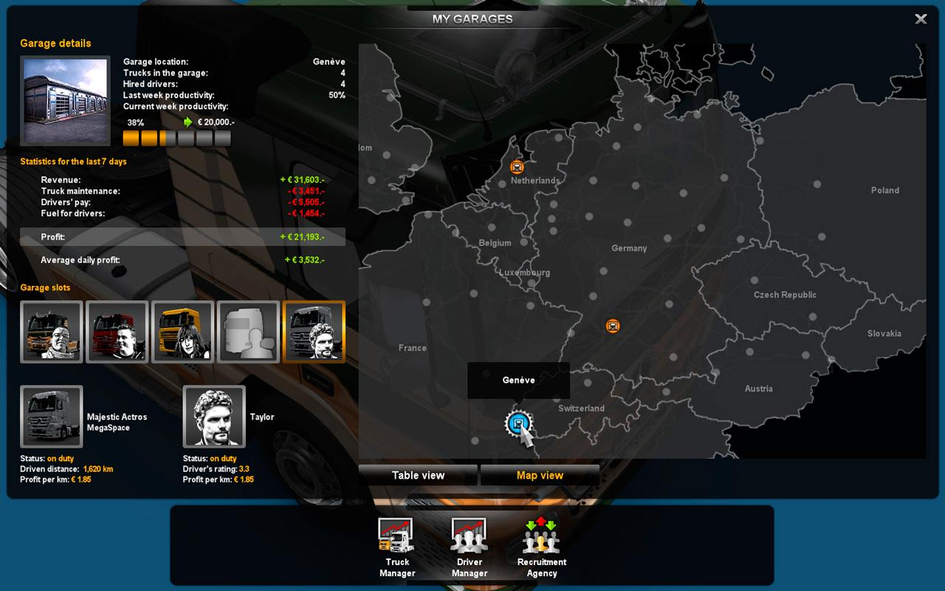

The game being programmed is an app that has a similar UI. The following are 3 methods that are unviable for the following reasons:

|  |  |
| --- | --- |
| **METHOD** | **REASON** |
| Past performance | No similar project have been created |
| Past experience on previous projects | No similar project have been created |
| Brainstorming sessions with team members | Not enough time to find people |

But we can try and use the following viable methods

|  |  |
| --- | --- |
| **METHOD** | **REASON** |
| Research material  (e.g Gamasutra post-mortems) | Internet have rich source of risk |
| Experts in the field | Can go to internet and chat with people |

The following potential risks will not be related to the project for the following reasons

|  |  |
| --- | --- |
| **METHOD** | **REASON** |
| Contractual risk | This will be no contractual in this project |

# Potential Risk

The following potential risks will be related to the project:

* Financial risk
* Legal risk
* Business risk
* Project risk
* Time risk
* Infrastructure failure
* Personnel Issues

The reason for these risks, failures and issues can be presented through the following example.

Table A below provides an explanation of the categories listed in table B.

TABLE A

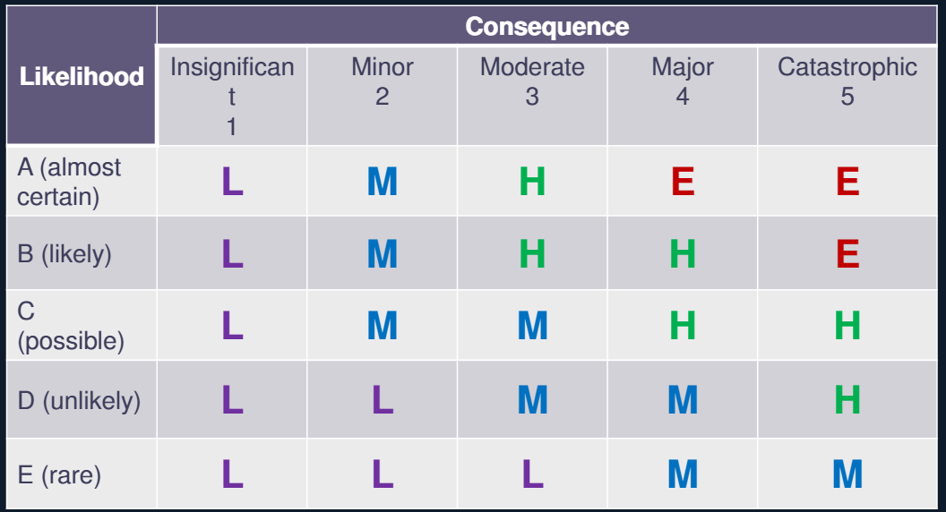

The Letters in the matrix represent the severity of each risk:

• L – Low Risk: Only worth dealing with if some simple, inexpensive system can be put in place

• M – Medium Risk: Worth thinking about some process or system to mitigate risk

• H – High Risk: Definitely should be considered, even if solutions are quite expensive

• E – Extreme Risk: Must be mitigated

– Consequence: Level of severity if it happens

– Likelihood: How often will that happen?

– Risk Assessment: The result of Consequence and Likelihood

TABLE B

|  |  |  |  |  |
| --- | --- | --- | --- | --- |
| **No** | **Risk Name** | **Type** | **Risk Assessment** | **Describe** |
| 1 | Income | Financial Risk | H | Lost income |
| 2 | Copyrights | Legal | L | Copyright issue was |
| 3 | Employee litigation | Legal | L | This can lead to losing money or give negative image to the public |
| 4 | Information security incidents | Legal | L | The risk of a security incident during the project (e.g. information is leaked). |
| 5 | Incorrect Requirements analysis | Project Risk | H | Can cause to use more time to finish the project |
| 6 | Hire a Incompetence person | Project Risk | M | This can slows down the project |
| 7 | Technological challenges | Project Risk | M | The code would need more time to be implement then we through |
| 8 | Poor Management | Time Risk | H | Ii4 |
| 9 | Teammates die | Personnel | L | Lead programmer or lead artist died in a car accident |
| 10 | Resources are inexperienced | Personnel | L | Resources who are just out of school or who are new to your industry or profession tend to make more mistakes and be less productive. |
| 11 | Teammates house fire | Personnel | L |  |
| 12 | Health issue | Personnel | L | Teammates make illness or other health problem that will slow down the project |
| 13 | Hiring takes longer than expected | Personnel | L | Couldn’t find any suitable person to hire |
| 14 | Poor relationships | Personnel | M | Poor relationships between developers and management slow decision making and follow through |
| 15 | time allocated | Time risk | M | Cannot build a product of the size specified in the time allocated |
| 16 | Product is larger than estimated | Project Risk | L | This can include (in lines of code, function points, or percentage of previous project’s size) |
| 17 | Scope is ill defined | Project Risk | L | The general risk of an error or omission in scope definition. |
| 18 | Low quality of change requests | Project Risk | M | Change requests that are low quality (e.g. ambiguous). |
| 19 | Cost forecasts are inaccurate | Personnel | L | Inaccurate cost estimates and forecasts |
| 20 | Hardware | Infrastructure failure | L | The hardware was broken and need to be replaced |

# Treatment plan

To able control/management the risk can choose the following three choice

* Eliminate the Risk
* Modify the Risk (size / shape / task / environment)
* Transfer the risk

|  |  |  |  |
| --- | --- | --- | --- |
| **No** | **Task Name** | **Treatment Plan** | **Describe** |
| 1 | Income | Modify the Risk | Try to lower the salary |
| 2 | Copyrights | Eliminate Risk | Try to find some lawyer first , if failed it maybe will cost to shut down the company |
| 3 | Employee litigation | Eliminate Risk | Try to find some lawyer first , if failed it maybe will cost to shut down the company |
| 4 | Solvency | Modify the Risk  Eliminate Risk | Try to find some finance people to help you to first ,if still cannot be done then  Shut down the project |
| 5 | Incorrect Requirements analysis | Modify the Risk | The risk would be reanalysis |
| 6 | Hire a Incompetence person | Eliminate Risk | Fire the person |
| 7 | Technological challenges | Transfer Risk | Hire a person or throw the solution to the internet |
| 8 | Poor Management | Modify the Risk | Hire a person that know how to management |
| 9 | Teammates die | Modify the Risk | Hire a another the person |
| 10 | Resources are inexperienced | Modify the Risk | Redo the resources |
| 11 | Teammates house fire | Transfer the risk | Allow other teammates do their work. |
| 12 | Health issue | Transfer the risk | Allow other teammates do their work or hire a new person |
| 13 | Hiring takes longer than expected | Modify the risk | Find another method to hire person |
| 14 | Poor relationships | Modify the risk | Try to sit down and chat if this happen often and give lack of the project ,hire a management |
| 15 | Time allocated | Modify the Risk | Delete some task that is not that important. |
| 16 | Product is larger than estimated | Eliminate Risk | Delete some task that is not that important. |
| 17 | Scope is ill defined | Modify the risk | Refined the task |
| 18 | Low quality of change requests | Modify the risk | Redo the task |
| 19 | Cost forecasts are inaccurate | Modify the risk | Write documentation and hire a manager |
| 20 | Hardware | Modify the risk | Buy new hardware |